**Micro Services**

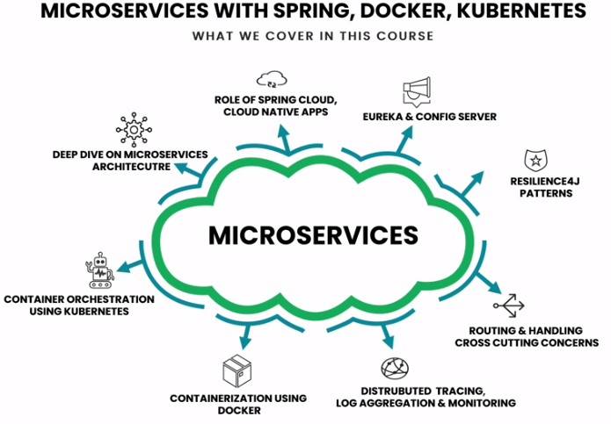

* **Micro services:** Micro services is an approach of developing single application as a suite of small services, each running its own process and communicating with lightweight mechanism (JSON, REST instead of SOAP), build around business capabilities and independently deployable by fully automated deployment machinery.

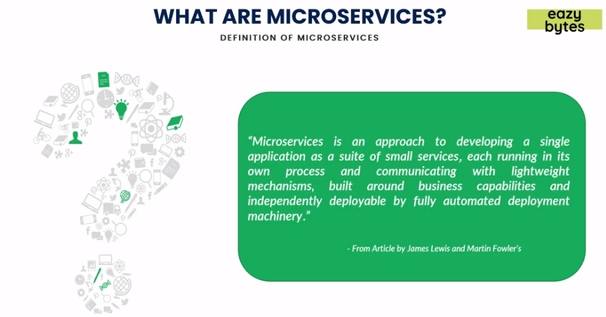

* **Architecture of Micro services:**

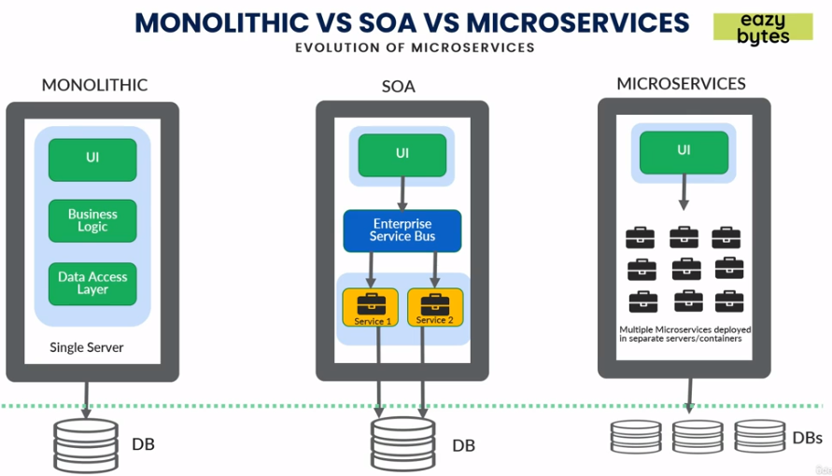

* + *Monolithic*: In monolithic architecture we had UI, Business logic, Data access layer etc deployed on a single server. It was complex as if we needed to increase nodes, then we needed to replicate same and have some load balancer between theses servers causing heavy load. Each team will checkout their code in common library like SVN or Github, from there Jenkins will club them into single package like EAR/WAR and deploy to single server (Websphere, tomcat etc)

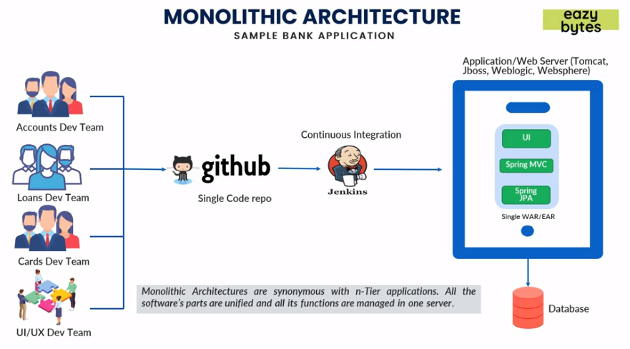

* + - *Pros*
      * Simple deployment good for smaller teams as all things are in same place.
      * Fewer cross-cutting concerns like security will be handled on a single server.
      * Better performance in terms network latency, as all things are on single server communications between layers has no latency.
    - *Cons*
      * Difficult to adapt new technologies as all layers need to be upgraded.
      * Limited agility as if we need to fix some bugs deployment will take huge time and need end to end test to make sure other features are not impacted.
      * Single code base and is difficult to maintain.
      * Not fault tolerance as if the server is impacted all services will be down.
      * Tiny updates require full deployment and impacting all other layers as well.
      * Tight coupling all layers are tightly tied together.

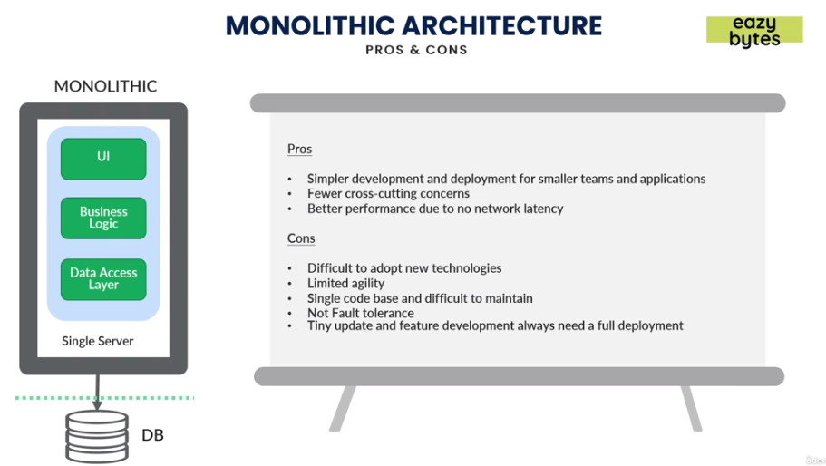

* + *SOA*: In SOA we expose or deploy the common services on different servers and UI could be on different servers and all these layers were connected using a proxy channel or Enterprise service bus. They usually follow SOAP which is restricted schema and is heavy for the business layers.

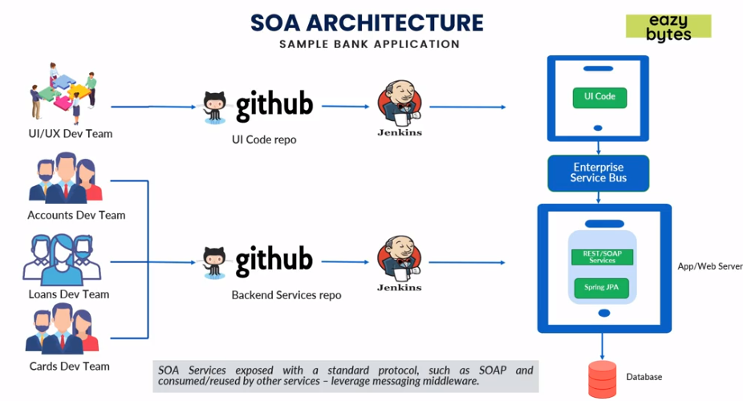

* *Pros*
  + Reusability of services as some business layers are independently deployed and can be exposed to other services as well.
  + Better maintainability compared to monolithic as some layers now are independent from each other.
  + Higher reliability.
  + Parallel development can be done now as some layers are separately deployed and tested.
* *Cons*
  + Complex management as we need different teams to manage different services.
  + High investment costs as for licensing separate components and need bigger team to manage.
  + Extra overload in managing some services.
  + Tight coupling still exists between some layers which are in single entity.

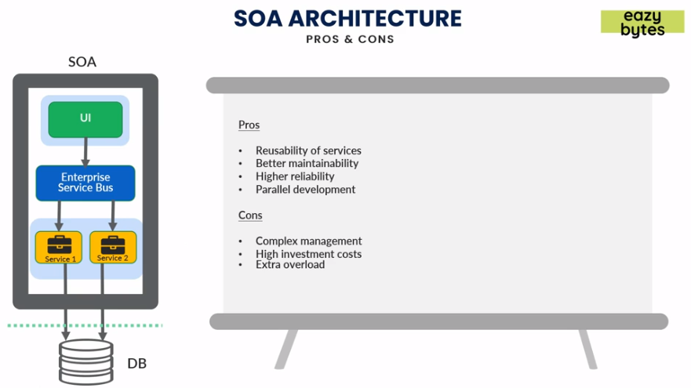

* + *Micro services*: In micro services all layers are deployed in separate containers. Each layer is independently deployed and can be worked on independently without affecting other services.

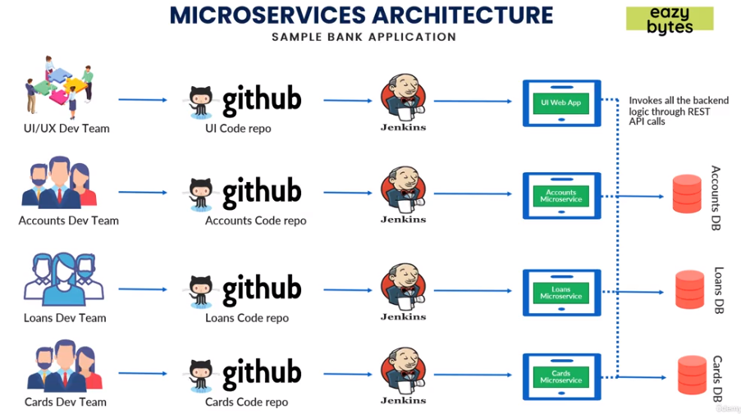

* *Pros*
  + Easy to develop, test and deploy as all layers are independent from each other.
  + Increased agility that is less downtime, faster deployment and fixing.
  + Ability to scale horizontally in case if some services requires much more compute power they can be scaled (manually or automatically) without affecting other services or downtime.
  + Parallel development can be done now as some layers are separately deployed and tested.
* *Cons*
  + Complexity as we need different teams to different services.
  + Infrastructure overhead monitoring different services and fallback mechanism like when some services is failing.
  + Security concerns as all services are now on different servers and need to be secure connection between them which is complex.
  + Loosely coupled services.

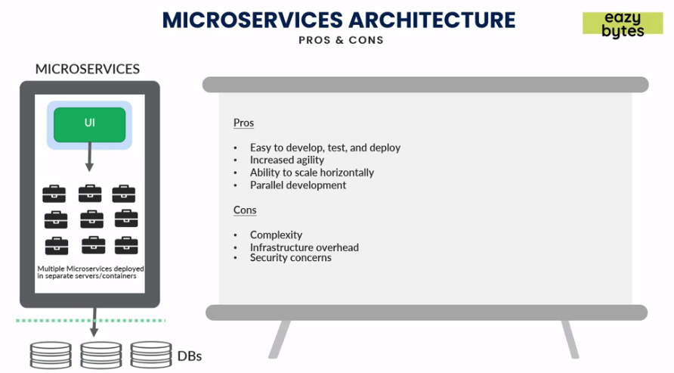

* **Monolithic vs SOA vs Micro services:** 
  + Monolithic is a *single unit*, SOA is *coarse grained* like only some services are coupled together and Micro services are *fine grained* and all services independent from each other.

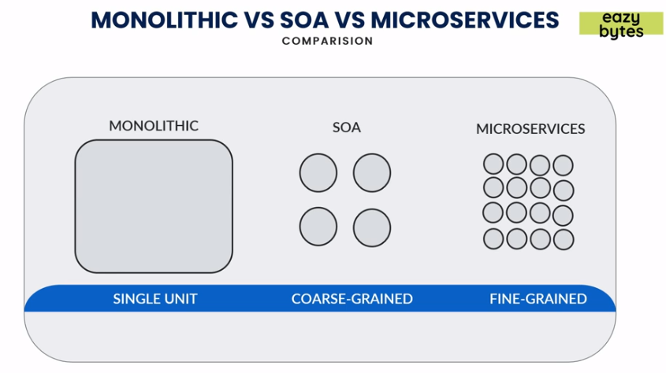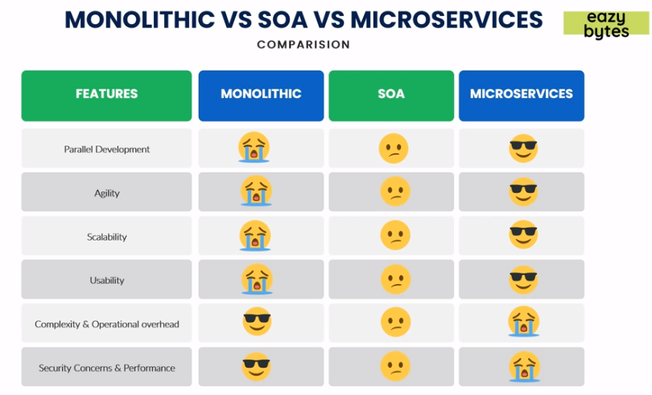

* **Why to use Spring for Micro services?**

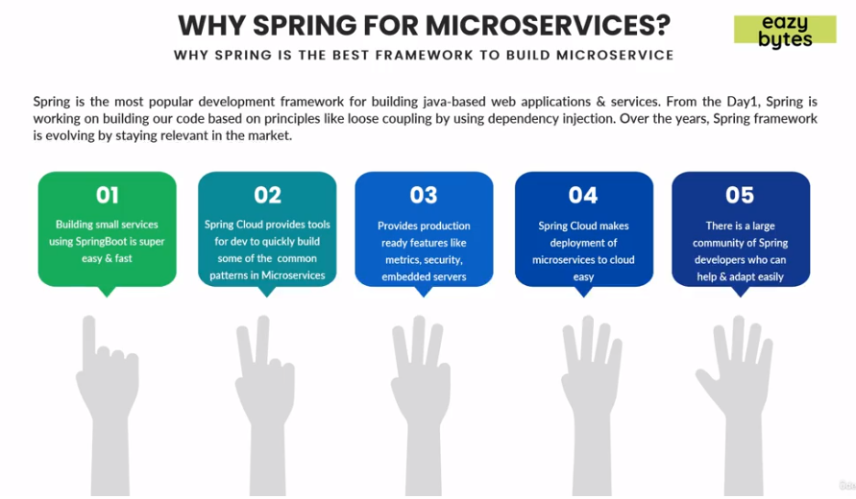

Spring is best and most popular framework for building web application and services. It has loose coupling using DI.

* + Building small services using Spring boot is easy and fast.
  + Spring cloud provides tools for dev team to quickly build micro services.
  + Provides production ready features like metrics, security, embedded servers etc.
  + Spring cloud makes easy deployment of services in cloud like GKE, Azure or AWS.
  + Spring is being used previously and lots of developers are already familiar which makes it to adapt easily.
* **Spring Boot:** Spring boot makes it easy to create stand alone, production grade Spring based applications that we can simply run.
  + *Standalone applications:* Creating standalone applications is very easy and quick.
  + *No need to deploy into server:* Embed tomcat, Jetty etc servers are available which we can deploy into directly.
  + *Starter project:*Bunch of starter projects are there for building REST, web applications etc.
  + *Auto Configuration:* Automatically configures Spring and other 3rd party libraries which are required.
  + *Production Ready Features:*With *Spring actuator* we can use inbuilt production ready features like metrics, health checks and externalizing configuration.
  + *Simple Configuration:*Provides many annotations to do simple configurations and instead of XML configuration.

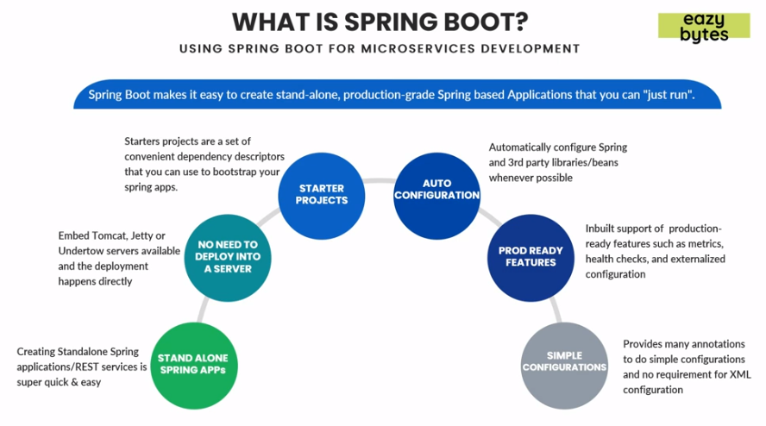

* **Spring Cloud:** Spring cloud provides tools for developers to quickly build some of the patterns of micro services.
  + *Spring cloud config:* For multiple instances of same application have a common same configuration.
  + *Service registrations and discovery:* With multiple instances being up scaled or downscaled, the services newly created will have different port or address. Through logical naming invoking them rather than the physical address.
  + *Routing and Tracing:* All calls to micro services shall pass through a single way or door before targeted services is invoked and calls will be traced to that service in case of failures.
  + *Load Balancing:* Using load balancer to efficiently distribute load (network traffic) amongst multiple backend servers or server pools.
  + *Spring Cloud Security:* Provides features like token-based security in Spring boot applications/micro services.
  + *Spring Cloud Netflix:* Netflix provided some tested Netflix components to Spring which includes Service Discovery (Eureka), Circuit Breaker (Hystrix), Intelligent routing (Zuul) and Client side load balancing (Ribbon).

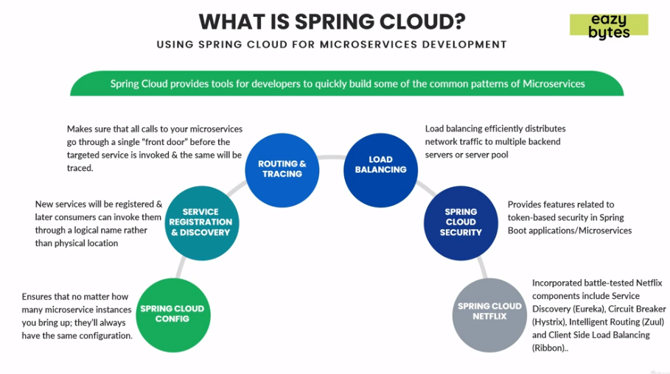

* **Challenges of micro services:** The most commonly followed approaches in the industry for identification of proper micro service boundaries and defining the size of each micro service are *Domain Driven Sizing* and *Event Storming Sizing.* 
  + *Domain Driven Sizing* is time taking process and we can size/define of micro services with Domain Driven design or business capabilities. (Based upon business features)
  + *Event Storming Sizing* is we need to conduct interactive fun sessions among various stake holders in the process of identifying micro services boundaries. (Based upon certain actions).

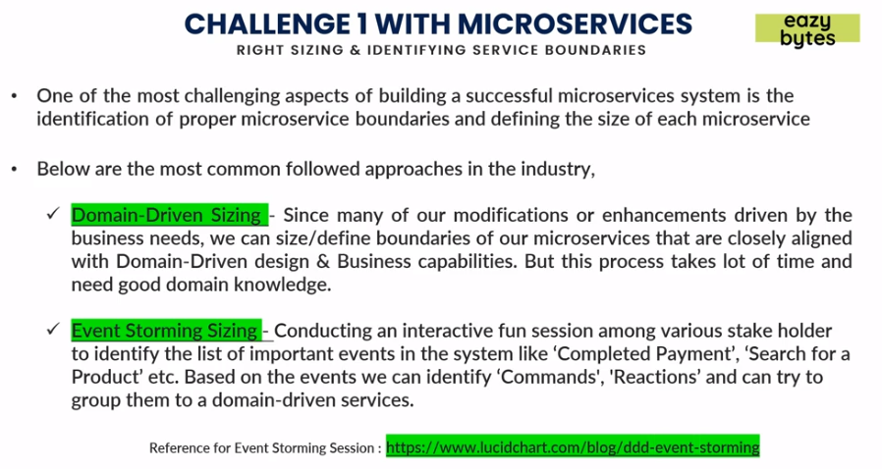

* **Right Sizing Micro services:** We need to make sure while sizing our micro service it shouldn’t be either too small or too large.

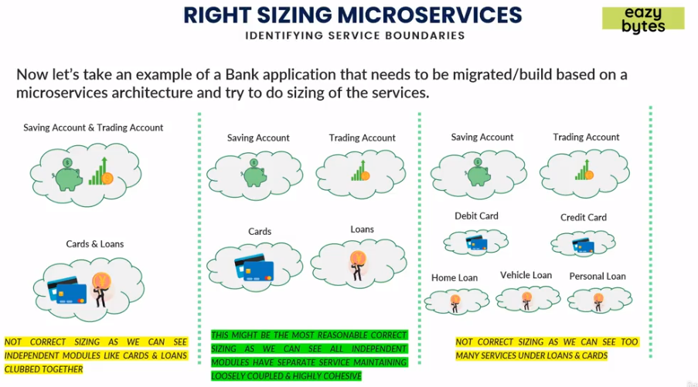

* **Monolithic architecture converted to Micro service:**

In this scenario an E-Commerce site decided to follow monolithic approach at start with small team, simple application (UI) connected with Backend process and a DB.

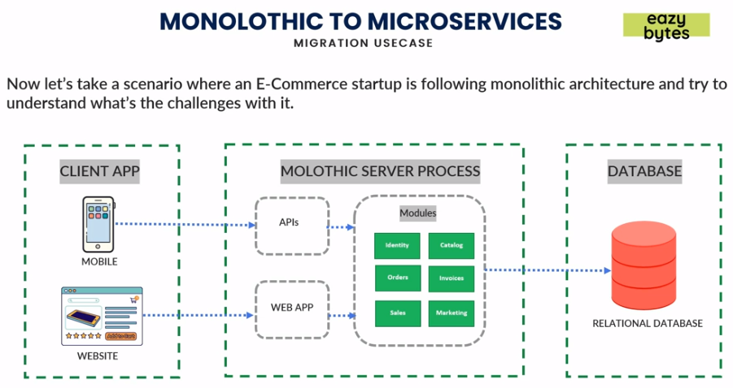

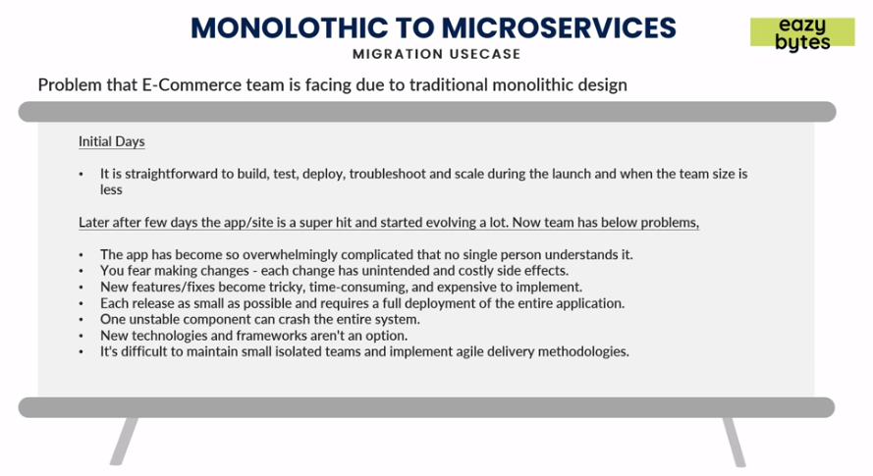

Now on later point of time they tried to switch to Micro services architecture and so they came up with keeping UI same, created a common API gateway which will connect with the services which can be connected to different Databases like RDBMS, MongoDB or Redis using JMS or event bus they send the messages and receive the messages.

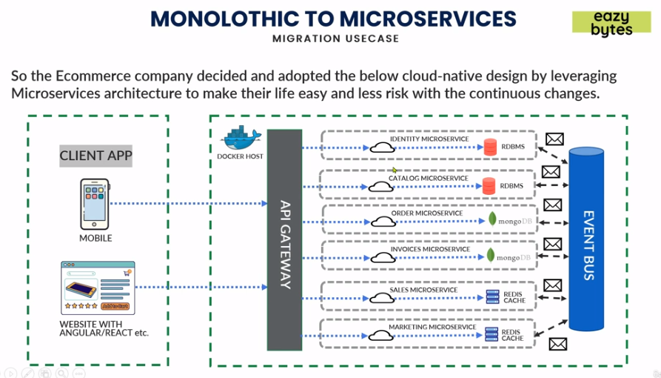

* **Installing Lombok in Eclipse:** 
  + Go to Help 🡪 Install New Software 🡪 Enter link ([*https://projectlombok.org/p2*](https://projectlombok.org/p2)).
  + Click Next 🡪 Next 🡪 Finish.
  + Restart Eclipse.
* **Docker:** Challenges with micro services if in 100s or more will be scaling, portability from one environment from other like DEV to UAT and managing deployment of these micro services can take lot of time and cost. To address this we have containerization technology like Docker helping in addressing these issues.

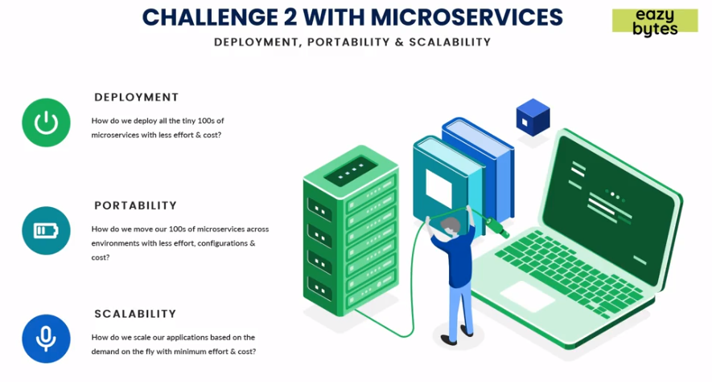

* **What is containerization?**
  + Usually in Cloud platforms like AWS, Azure, GCP etc virtual machines are allocated for each application to be deployed in cloud. *Hypervisor* is responsible for allocating the resources like how much memory, CPU for each VMs. All the VMs will have separate OS with them and it makes scaling a little bit slower when compared to Containers.
  + Containers makes deployment and scaling fast as they don’t have Guest OS instead they have a common OS and Container/Docker engine helps in allocating the resources just like Hypervisor and each micro service is isolated from each other just like VMs.

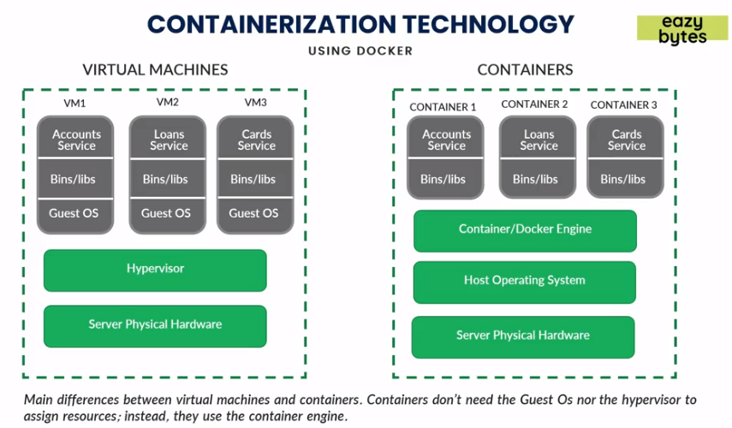

* + **Containers:** *Containers* are loosely isolated environments which contains the software and dependencies and that can be run in any computing environment (AWS, Azure, GCP). These packages are called container images.
  + **Software Containerization:** *Software containerization* is a method of OS virtualization and is used to deploy/run containers without VMs. It can run on physical hardware, Cloud, VMs etc.
  + **Docker:** *Docker* is one of the tools that use the idea of isolated resources to create a set of tools that allows application to be packages with all dependencies installed and run wherever wanted. It handles scaling, deployment portability etc.

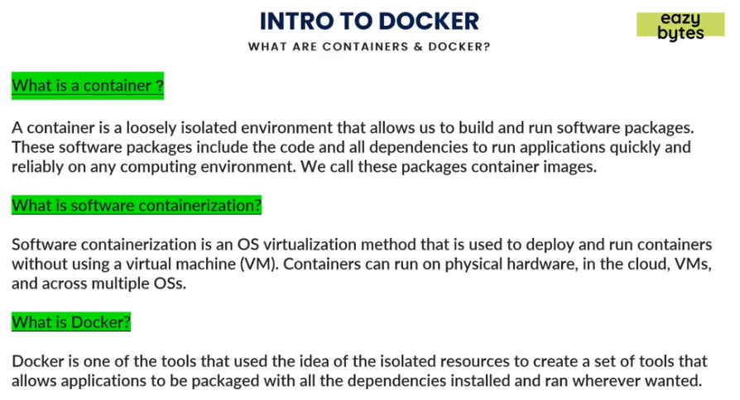

* **Docker Architecture:** 
  + *Docker Client:* We can issue commands to *Docker Daemon* using either CLIs or APIs. Just like Gitbash.
  + *Docker Host/Server:* Using *Docker Daemon* we can create and manage these Docker images. *Images* are just like java classes and *Containers* are like objects of these classes. In other words we can have multiple objects of same class just like that we can have multiple containers for a single image. *Containers are instances of images.*
  + *Docker Registry:* It is similar like to Github (repo/link) where all the Docker images are stored. Docker images can be maintained and pulled from the *Docker hub* or *Private registries.* In case if someone has Docker image they can access our Docker images and in case we need to keep it private we can do that as well using *Private registry.*

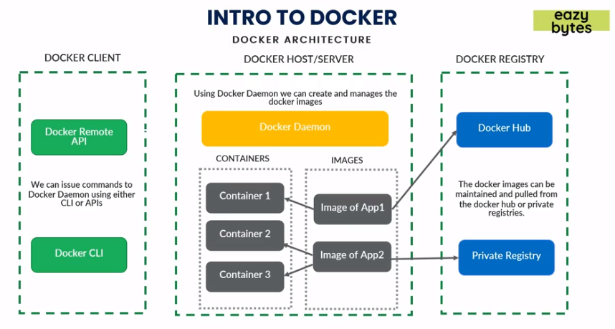

* **Steps to create a Docker image:**
  + In pom.xml we can define the type of packaging like *<packaging>jar/war</packaging>.*

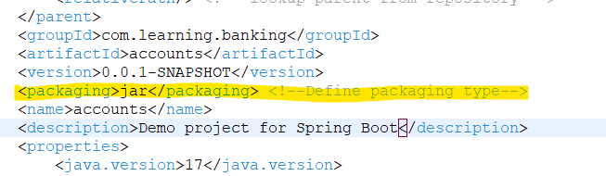

* + Do *mvn clean install* it will create a *jar/war* file in the *targets* folder.

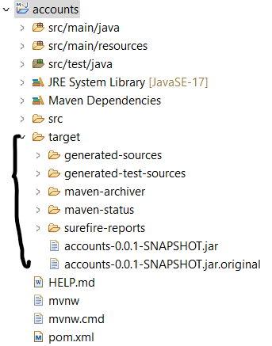

* + Running the jar file can be done with Spring command: *mvn spring-boot:run* or using Java command: *java –jar <jarName>.jar.*
  + Create a *Dockerfile* with no extension as Docker automatically reads this file.
    - *FROM <JDK_IMG> AS BUILD* 🡪 Commands will look for jdk on Docker Hub if not found will download to local.
    - *COPY target/<JAR_FILE> <FS_JAR_FILE>* 🡪 Command will copy the *target* folder jar file to container File system. Note each container will have its own File system allocated/created.
    - *ENTRYPOINT [“COMMANDS”]* 🡪Commands to run the jar file in container File system.

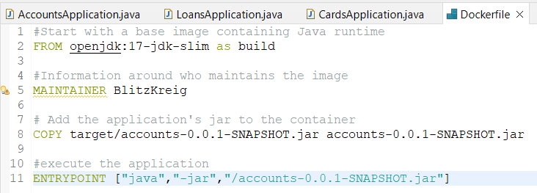

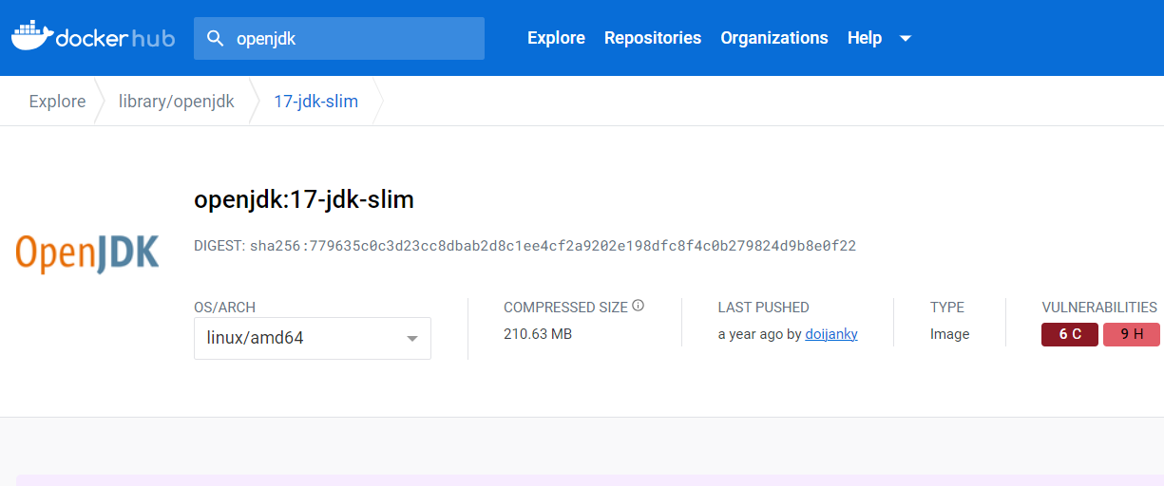

* + Open command prompt and go to the location where code is located and to create Docker Image type following command. *docker build . -t <Tag_Name>.* In the command *build* will create an image, *(****.****)* indicates that the *Dockerfile* is present in the same folder. *–t* is for creating a tag name to the image. As we can see in cmd it will look for required Docker images and download it and then execute rest of the commands. We can use *docker inspect <IMG_ID>* to get Image definition in CLI.

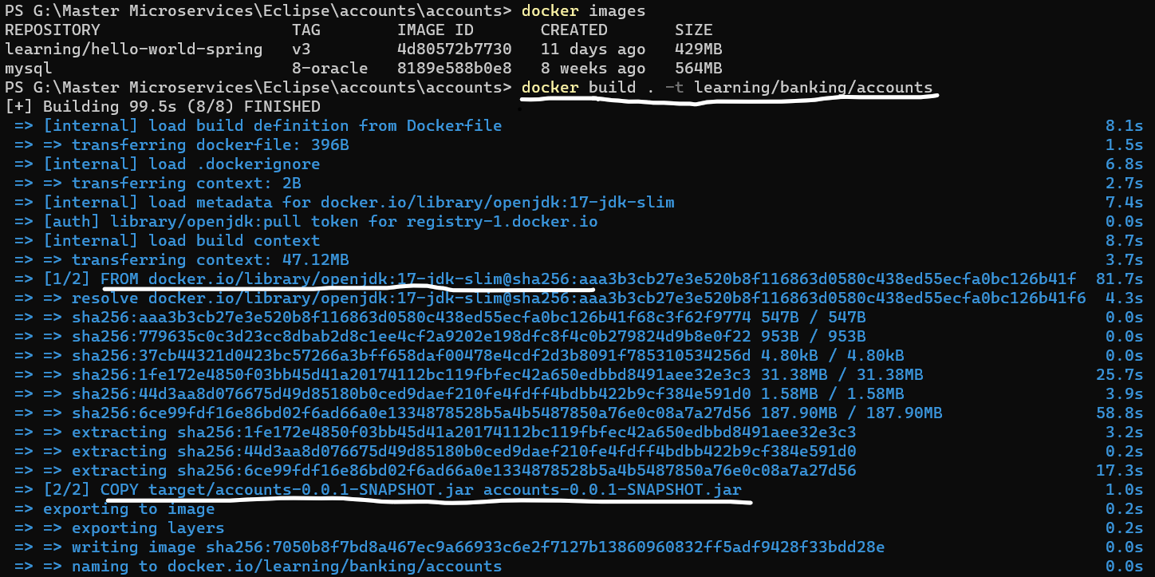

* + Run created Docker Image using *docker run –p <host_port>:<container_port> <IMG_ID>.*
    - *<host_port> 🡪* Port on which we need to expose the service, it can be different from *<container_port>.*
    - *<container_port> 🡪* Port on which the application should run inside container.

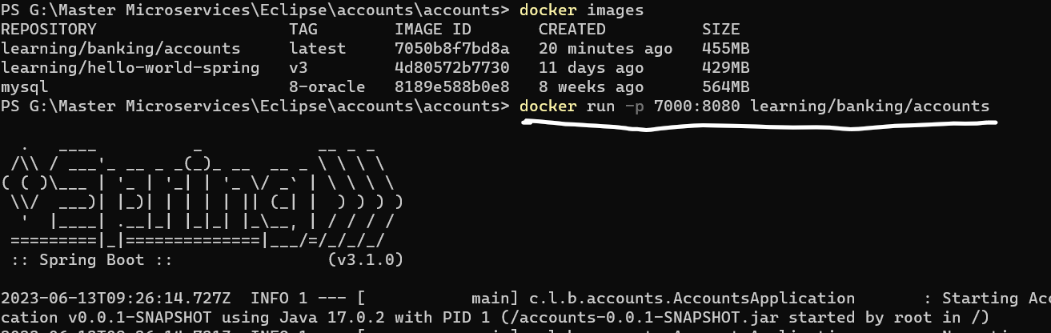

* **Important Docker commands:**
  + - *docker ps:* Shows running containers.
    - *docker logs -f <CONT_ID> 🡪* Shows logs of Docker container.
    - *docker ps –a 🡪* Shows all the container running or stopped.
    - *docker stop <CONT_ID> 🡪* Stops the Docker container.
    - *docker start <CONT_ID> 🡪* Starts the Docker container.
    - *docker container pause <CONT_ID> 🡪* Pause the Docker container, that will not accept any requests.
    - *docker container unpause <CONT_ID> 🡪* Resume the Docker container.
    - *docker kill <CONT_ID> 🡪* Instantly terminates the running Docker container.
    - *docker stats 🡪* Provides stats and metrics of running Docker container.
    - *docker rm <CONT_ID> 🡪* Removes the existing Docker container.
    - *docker run –d –p <host_port>:<container_port> <IMG_ID> 🡪* Runs Docker image in detached mode i.e., with no logs.
    - *docker push <IMG_ID> 🡪* Pushes latest Docker image to Docker hub.
    - *docker pull <IMG_ID> 🡪* Pulls Docker image to Local.
* **Build packs:** A *build pack* will transform your code into runnable application image without the need of Docker file. For Java we use *Packeto* build pack.
  + Add following configuration in the pom.xml.

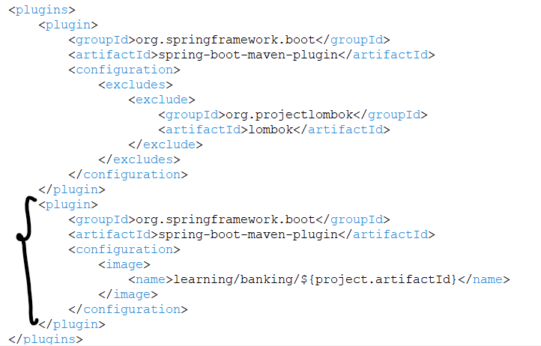

<build>

<plugins>

<plugin>

<groupId>org.springframework.boot</groupId>

<artifactId>spring-boot-maven-plugin</artifactId>

<configuration>

<image>

<name><TAG_NAME>/${project.artifactId}</name>

</image>

</configuration>

</plugin>

</plugins>

</build>

* After adding the above dependency run the following command to create a runnable image *mvn spring-boot:build-image.*
* We can make Docker repository private, we can also do that but it will be paid plan.
* Making Docker repository private 🡪 Go to Docker Hub 🡪 Go to repository 🡪 Select Image 🡪 Settings 🡪 Make private.

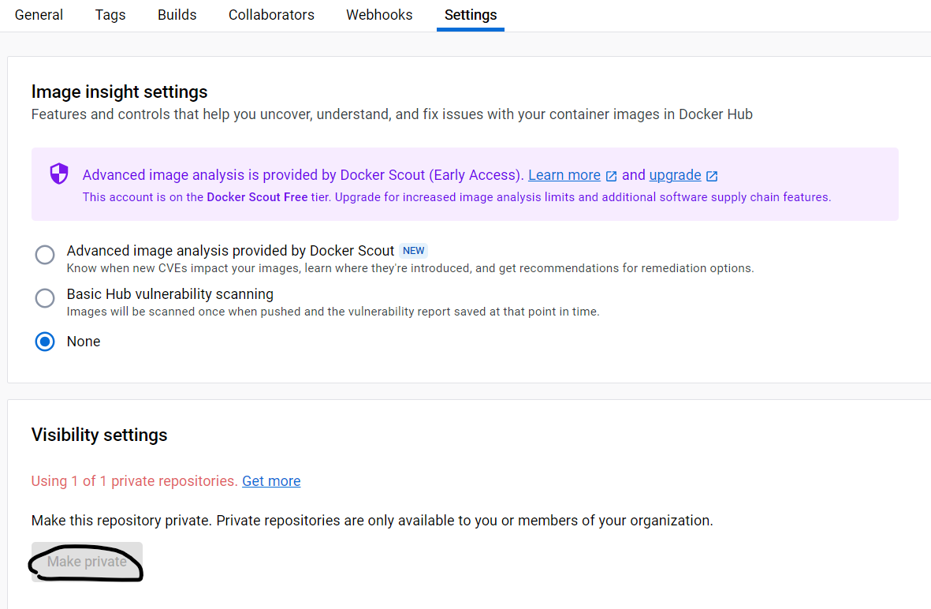

* **Docker Compose:** *Docker Compose* is a tool for defining and running multi-container Docker applications. With Compose, we need a YAML file to configure application's services. We can get version for Docker-compose yaml file from <https://docs.docker.com/compose/compose-file/compose-file-v3/>.

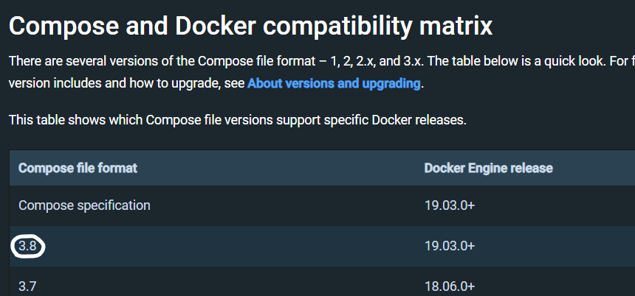 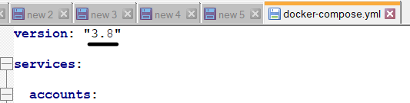

* + Files should be named as *docker-compose.yml, compose.yml, docker-compose.yaml, compose.yaml* and placed into the root folder.



* + Command to run configuration from docker-compose.yml:*docker-compose up*
  + Command to stop from docker-compose.yml:*docker-compose stop*
* **Cloud Native Applications:** It is a collection of small, independent, loosely coupled services which deliver some business values. If an application is cloud native it is designed to provide continuous development, automated management across private, public, hybrid clouds.

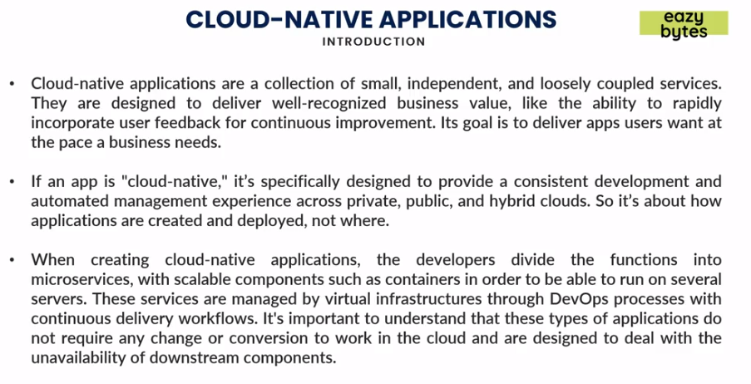

* **Principles of Cloud Native applications:** 
  + *Micro service:*Breaks applications into small components independent from each other.
  + *Containers:*Containers are packaged application with dependencies which makes it easy to move to any environment with full functionality.
  + *DevOps:* It is an approach to culture, automation and platform design intended to deliver business values.
  + *Continous Delivery:*Software development practice in which the process of delivering software is automated to allow short time deliveries.

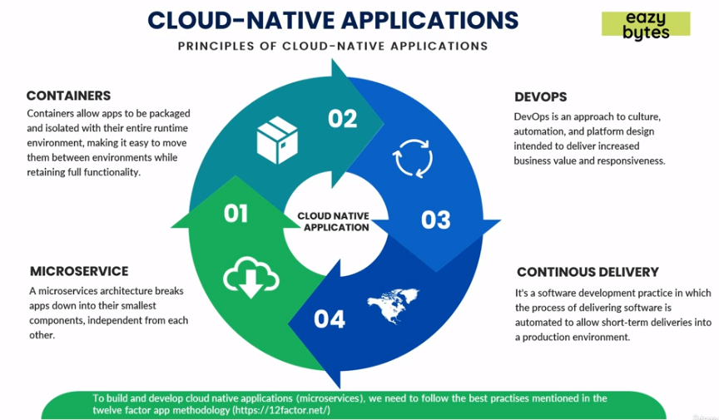

* **Difference between Cloud Native application and Traditional Application:**
  + Cloud Native applications are *predictable in behavior* which means if something or some instance goes down, it will auto manage and create new instance instead of letting whole system down.
  + Cloud Native applications are *OS abstracted*, using Docker we can deploy our applications in any OS (Win, Linux, AIX) which was not the case with traditional applications.
  + Cloud Native applications are *right sized* (number of instances based upon usage) and independent from each other.
  + Cloud Native applications implement *continuous delivery approach* i.e., development is easy and faster without bringing down whole system for deployment.
  + Cloud Native applications have *rapid recovery* as the downtime is very less and can recover automatically in case of failures in any instances.

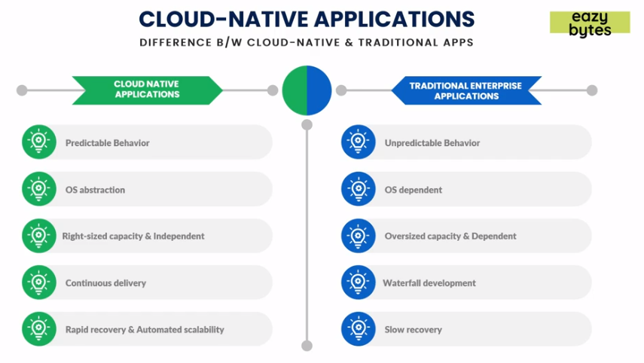

* **12 factor App:** There are 12 factors which are best practices for Cloud native application.

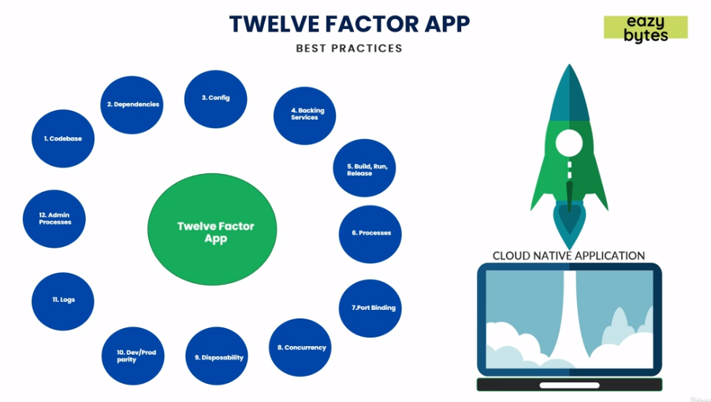

* + **Code Base:** Each micro service should have its own codebase and managed using source control like github.

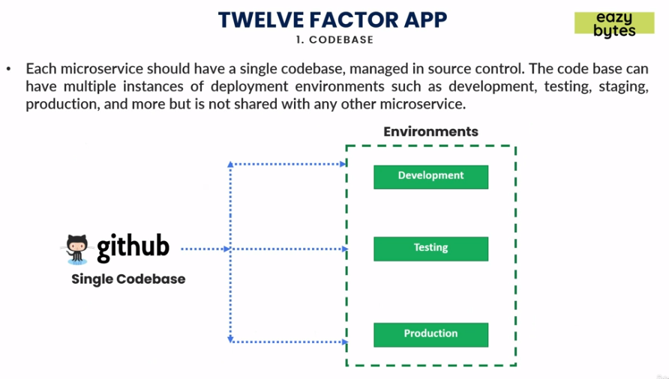

* + **Dependencies:** Dependencies should be declared using build tools such as Maven or Gradle. It should not be like we can add dependencies once Docker image is created.

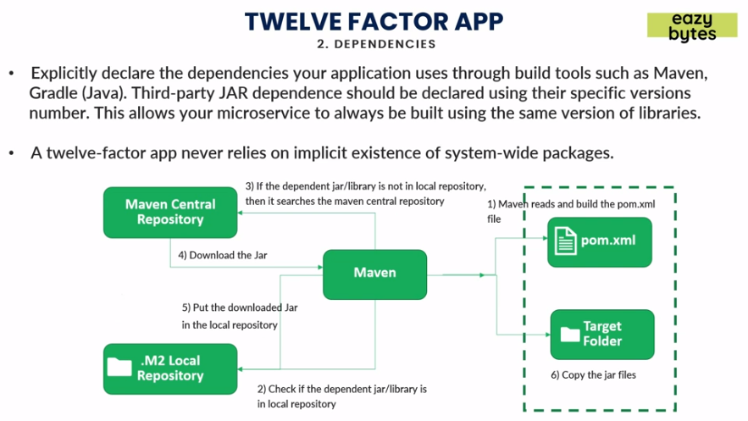

* + **Configuration:** Storing of environment specific configuration independently instead of hard coding inside the code.

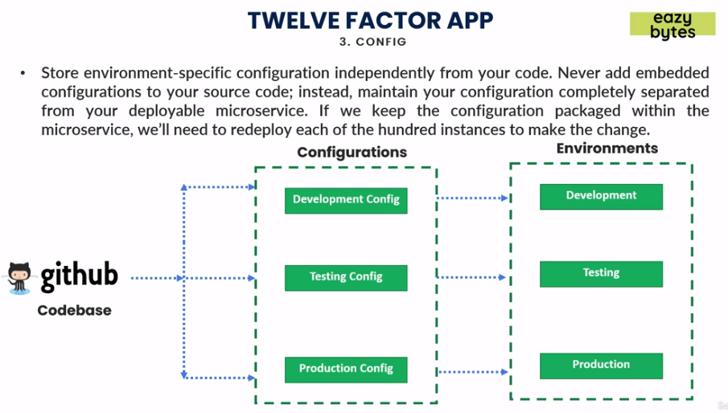

* + **Backing service:** Easy switching of connections from local to third party connections.

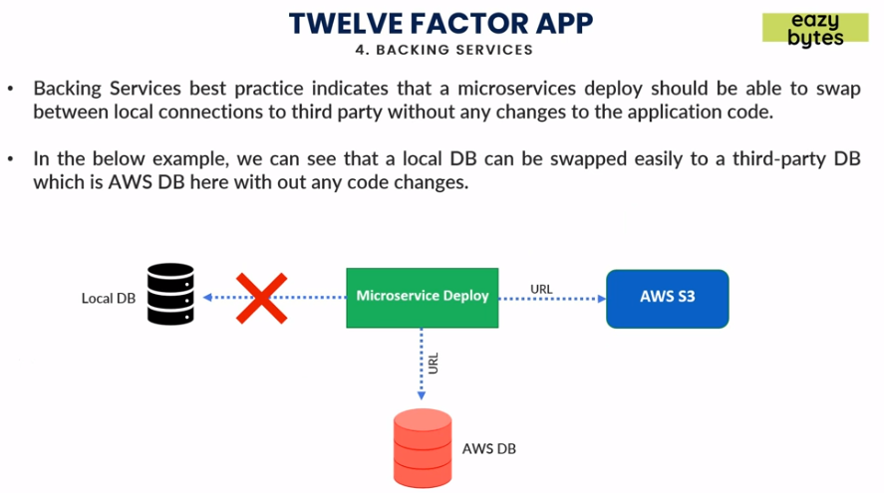

* + **Build, run and release:** Keeping build, release and run stages of deploying applications separate from each other. The process of build should not vary environment to environment.

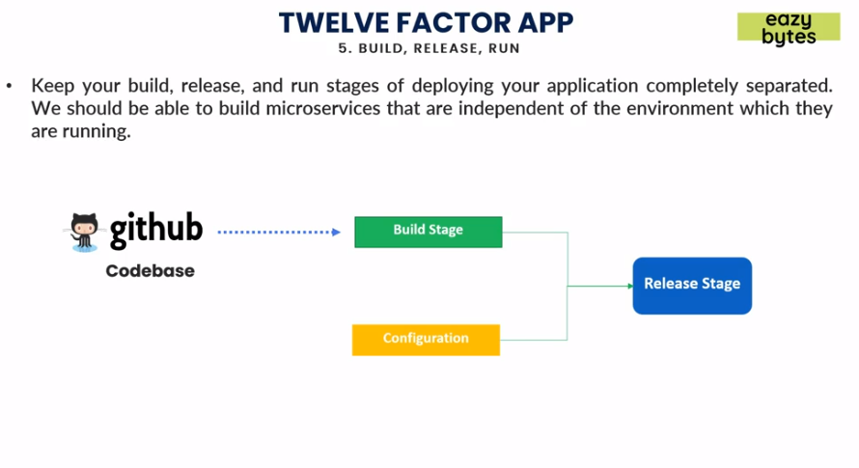

* + **Processes:** We could have multiple micro service interacting with each other and they should be stateless by mean not storing any session details or data that can be lost once if one micro service goes down impacting communication with others.

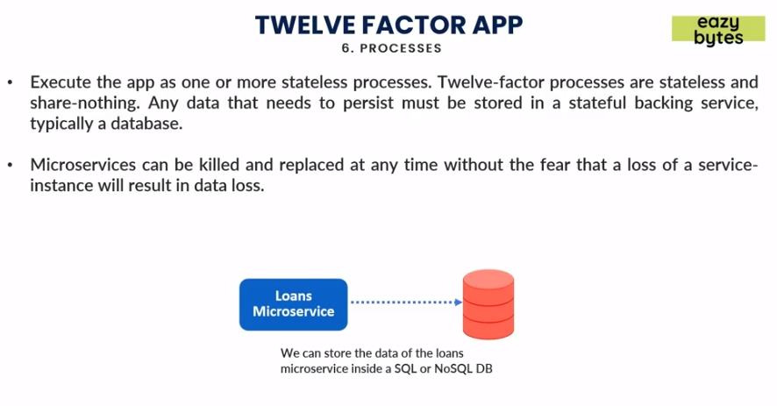

* + **Port Binding:** Ports of each micro service should not be same and have their own ports defined providing isolation.

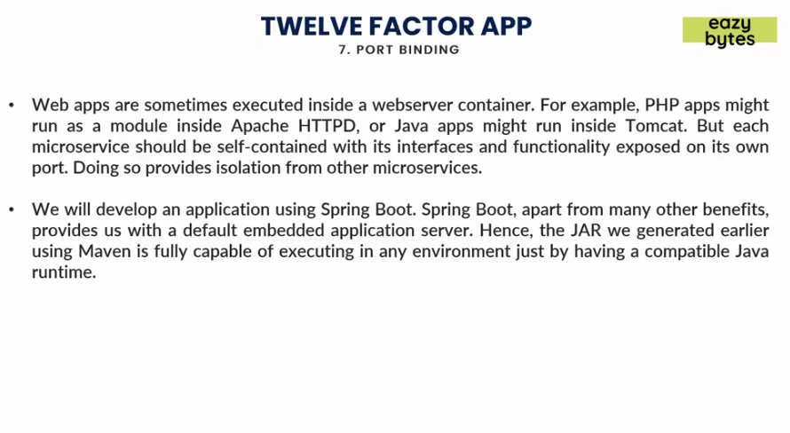

* + **Concurrency:** *Vertical Scaling* refers to increase of resources whereas *Horizontal Scaling* refers to adding more instances. The best approach recommended is *Horizontal Scaling* instead of *Vertical Scaling.*

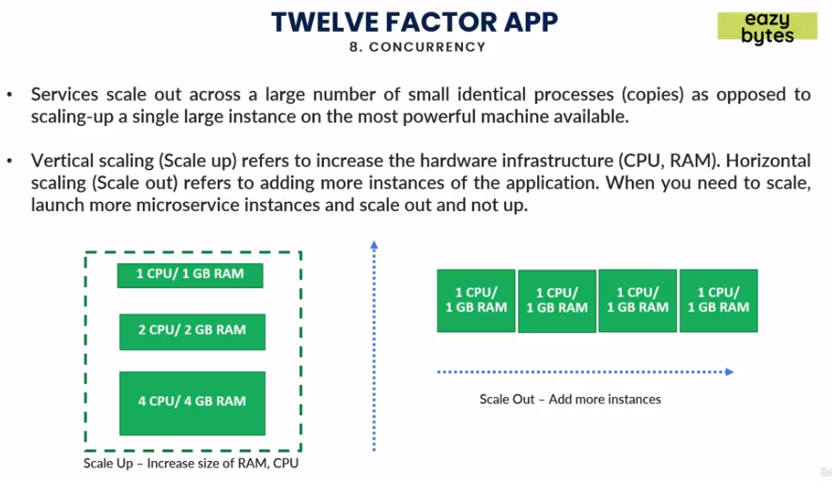

* + **Disposability:** Instances should be easy to shut down or dispose, favoring fast startups, for that we can use Orchestrations tools which can manage in the case of failure it should replace corrupt instance with new one.

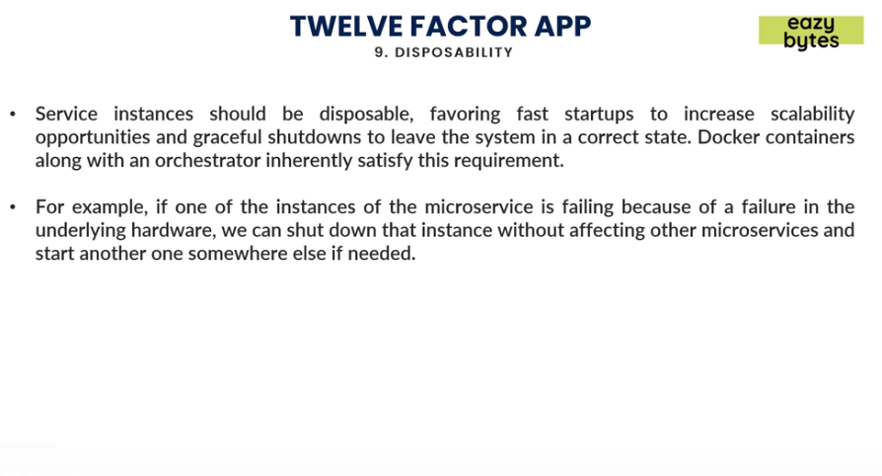

* + **Dev/Prod Parity:** Keeping all environment as similar as possible. If some code is changed and then tested it should go once promoted from Dev to all the way to production.

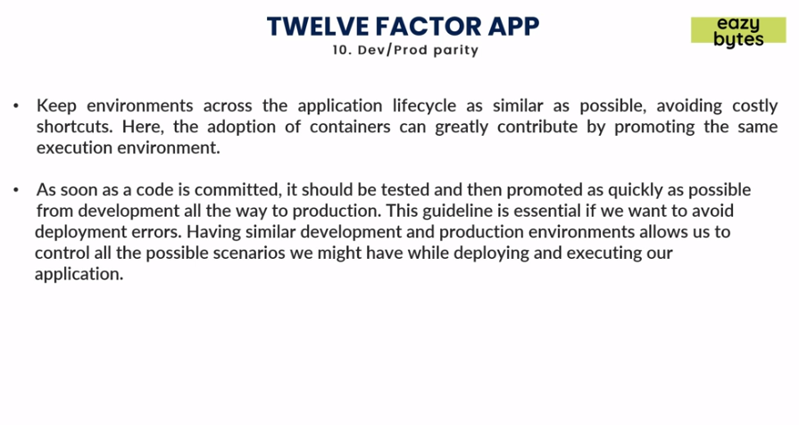

* + **Logs:** Logs should be generated as event streams and should be managed using tools such *Logstash* that will collect logs and store it in location.

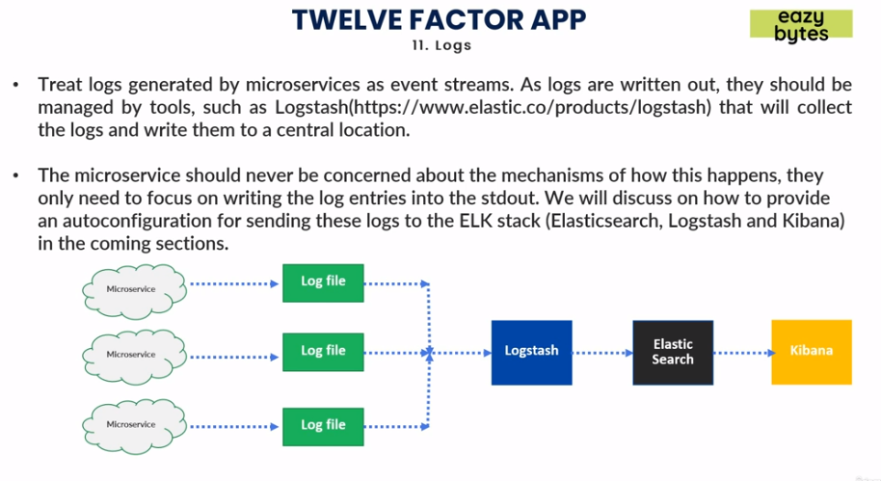

* + **Admin Processes:** Some of admin tasks like cleanup process or pulling reports should be separate from the application.

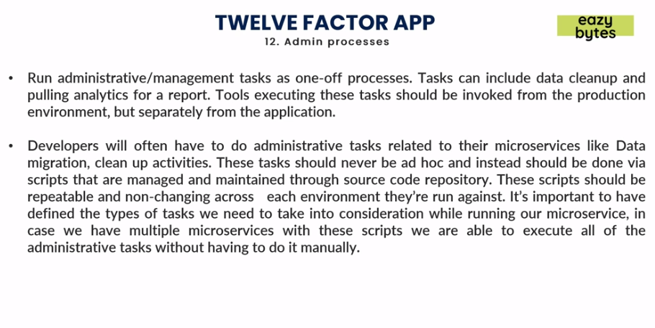

**Configuration Management:** We need to have maintain Configuration properties in a centralized system like Github/DB/File system, Inject these configuration into micro services using CMS (Configuration Management Service) and for each environment all the configurations should be separated.

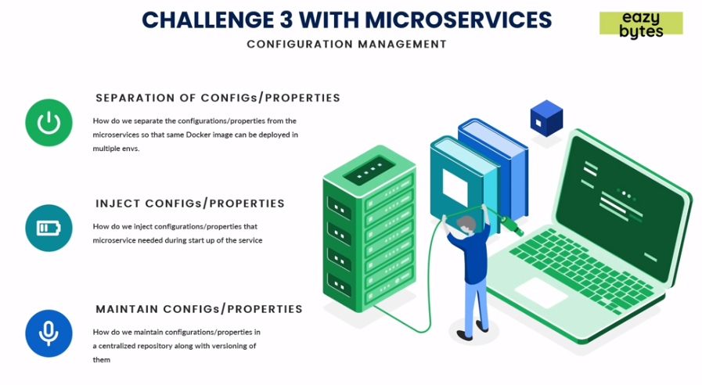

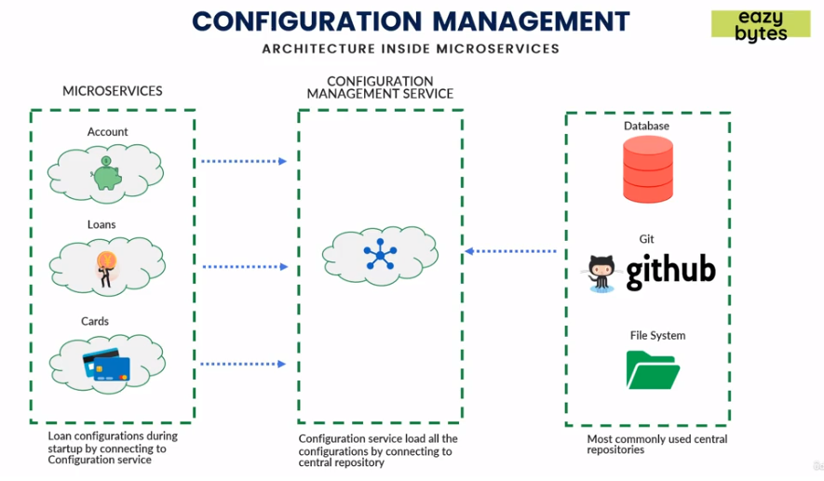

**Spring Cloud Configuration:** Spring Cloud Configuration provides server and client side support for externalized configuration, so that so Github will contain all properties CMS will manage and expose properties via APIs which can be used by micro services.

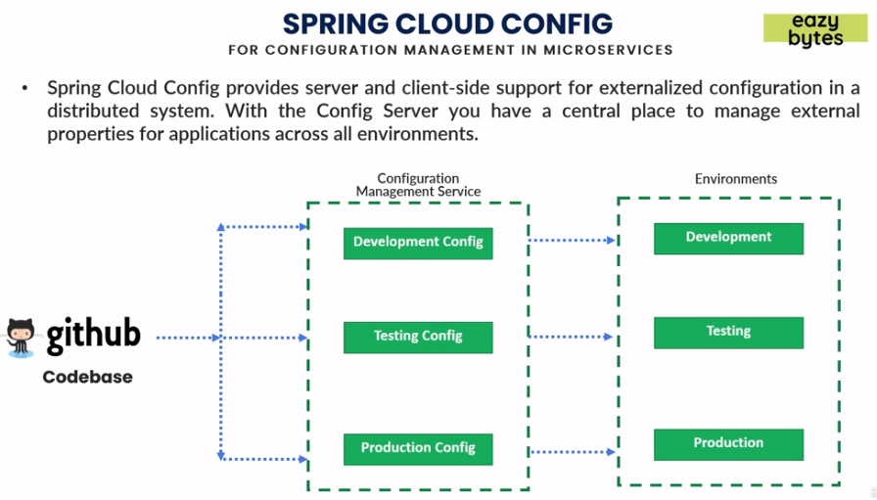

* **CMS Server features**
  + HTTP or resource-based API for external configuration.
  + Encrypt and decrypt property values.
  + Embeddable in Spring boot application using *@EnableConfigServer. '@EnableConfigServer'* annotation will make your micro service to act as a Spring Cloud Config Server.
* **CMS Client features**
  + Bind to the Config server and initialize with property sources.
  + Encrypt and decrypt property values.

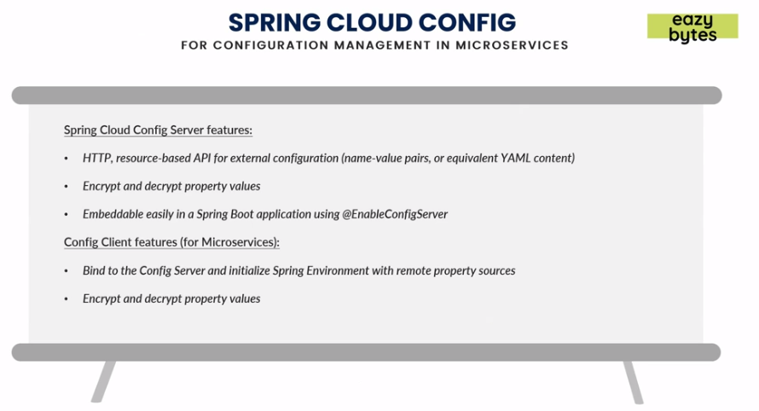

* **Creating a CMS server:**
  + Create a Spring starter project with adding dependencies for spring boot actuator and spring-cloud-config-server.
  + Enable main class with *@EnableConfigServer* annotation will make your micro service to act as a Spring Cloud Config Server.

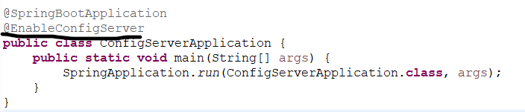

* + Add all configuration files in the *src/main/resources* folder.

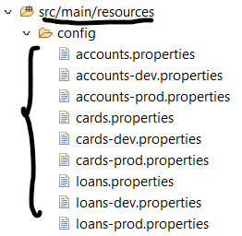

* + Add following properties in *application.properties*. Note we are using native in case the properties are stored in the project itself otherwise it will be *git* for github.

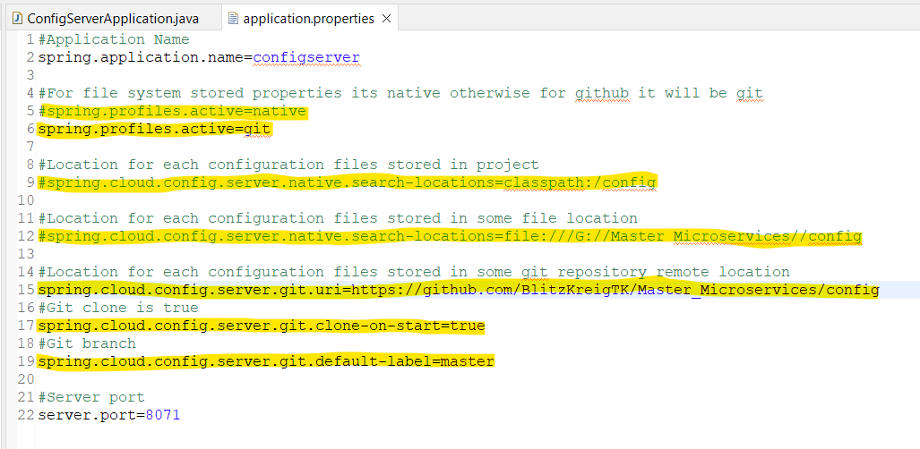

* + Run the application main class and hit the url, */default* will show the default properties only. */dev* or */prod* will have dev or prod properties followed by default properties so in case of some missing values in dev or prod they will show the value present in default properties.

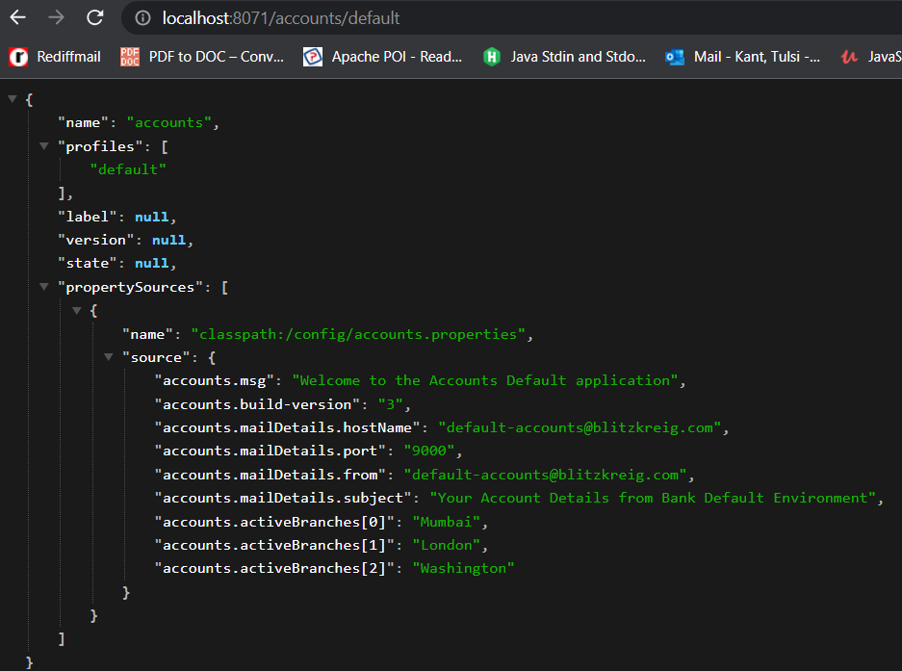

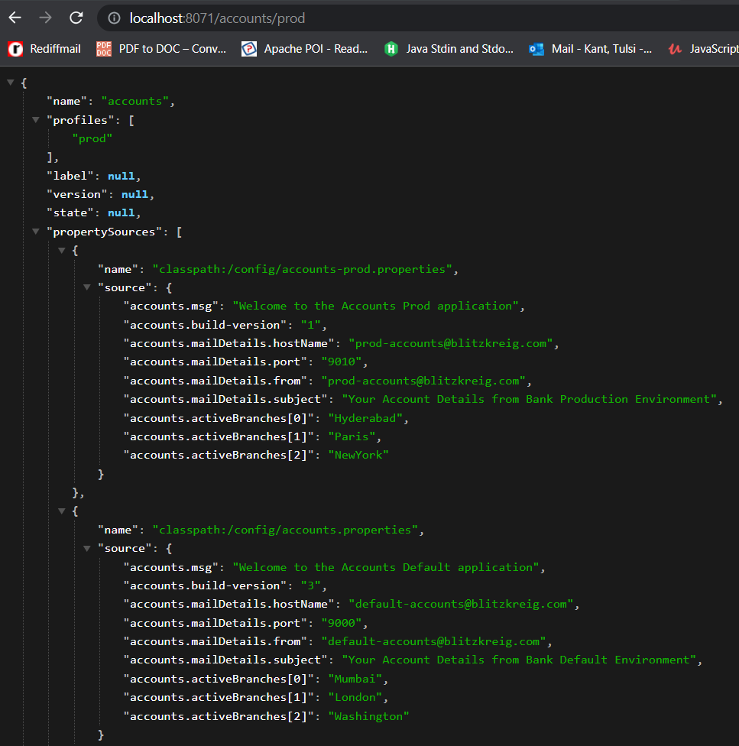 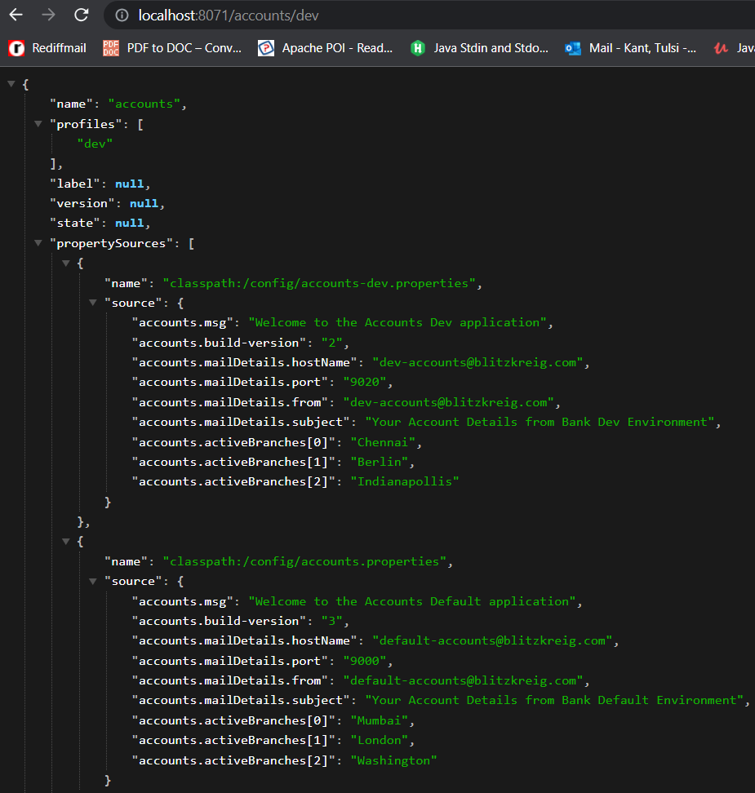

* **Read from CMS server:**
  + Add following dependency in *pom.xml* of application.

<dependency>

<groupId>org.springframework.cloud</groupId>

<artifactId>spring-cloud-starter-config</artifactId>

</dependency>

* + Create a config class to map properties from CMS server into JSON.

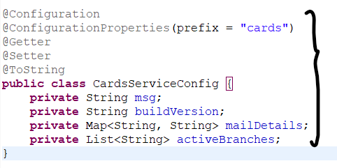

* + In *application.properties* add below properties.

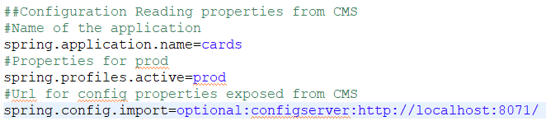

##Configuration Reading properties from CMS

#Name of the application

spring.application.name=<Application_Name>

#Properties for environment name

spring.profiles.active=<Environment_Name>

#Url for config properties exposed from CMS

spring.config.import=optional:configserver:url

* + Access properties anywhere by injecting or autowiring the config class.

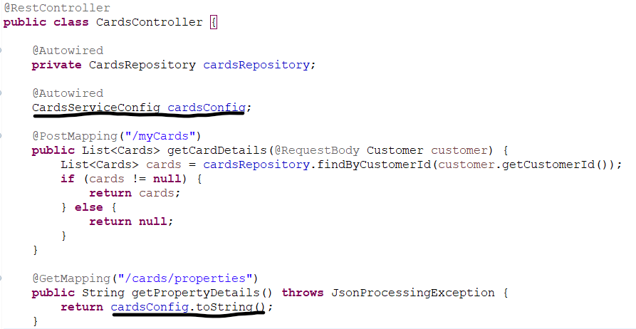

**Sample yaml to restart all Docker containers with config server service:**



**@RefreshScope:** This annotation is used to refresh the properties in application updated in configurations which will not require startup on application level. For example if we modify DB connection details in CMS it will require application to restart to take effect of new changes. We can invoke a *refresh url* by making a post call to the *actuator provided refresh url.*

* Add following properties in *application.properties.*

#To expose /refresh url by actuator

management.endpoints.web.exposure.include=*

* Add *@RefreshScope* in main class*.*

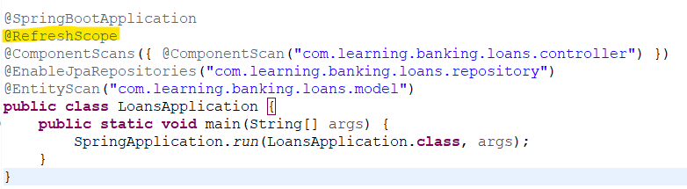

* Do a post call to the url *http://<server>:<port>/actuator/refresh* to refresh properties.

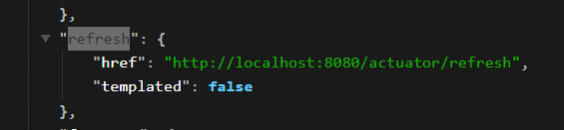

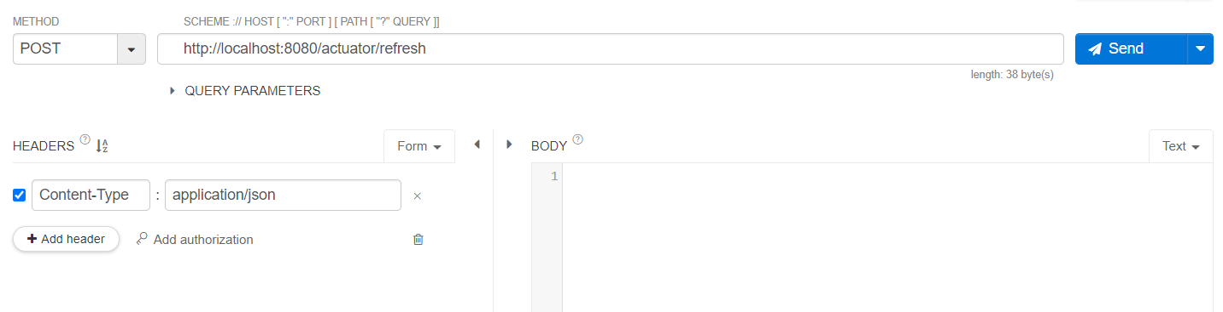

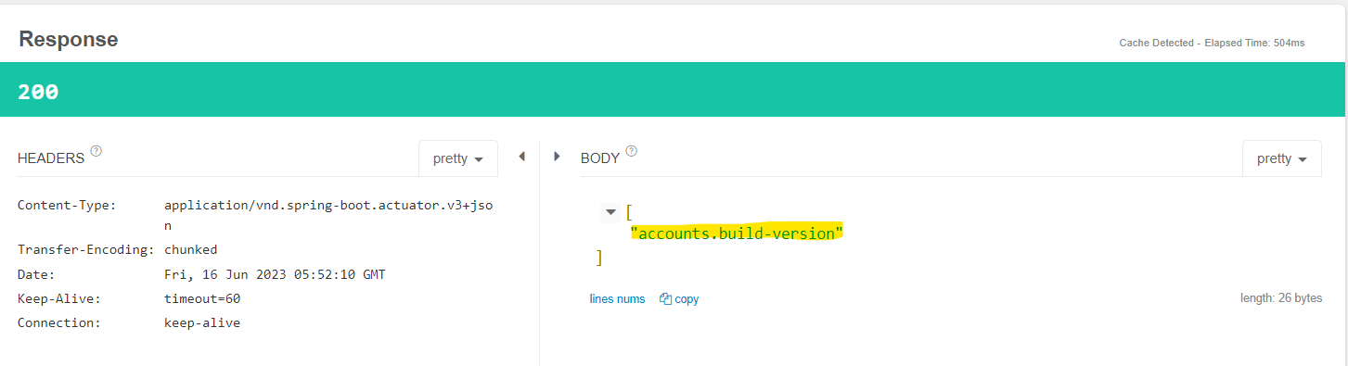

* **Encrypt/Decrypt Configuration:**
  + First add the following properties in the CMS *application.properties.*

#Encrypting key

encrypt.key=blitzkreig

* + Start CMS and do a POST call to */encrypt* url and pass text we want to encryptand in case we need to decrypt encoded value, we can do similar thing with */decrypt* url.

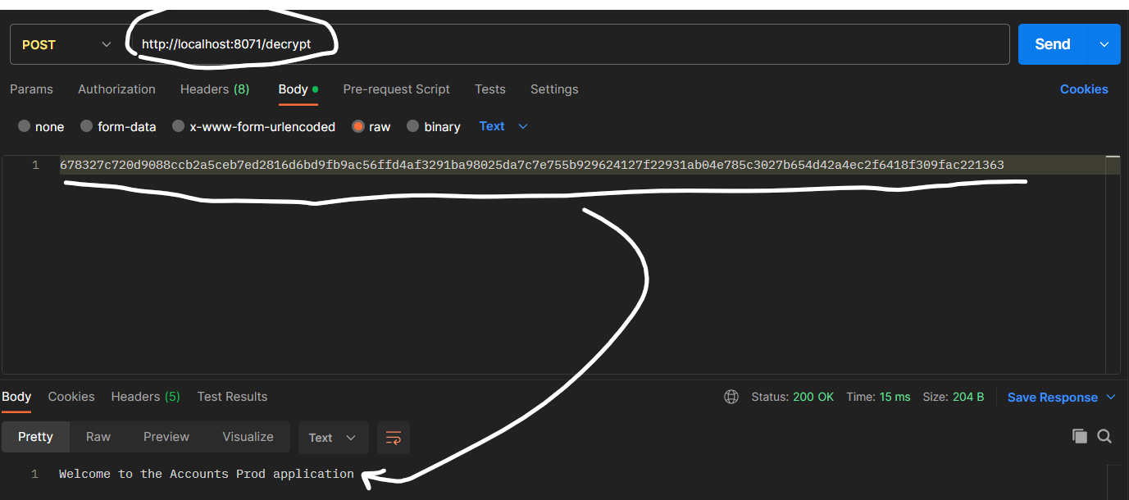 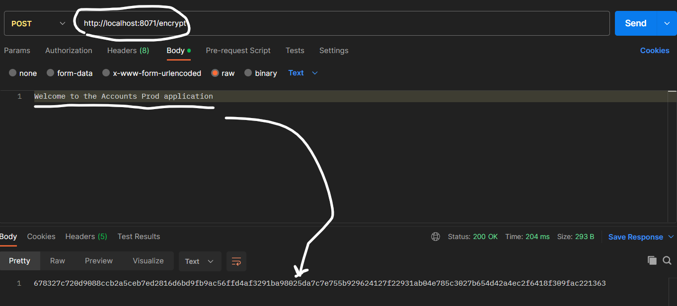

* + In *application.properties* for application, we need to add encrypted value with *{cipher} <Encrypted_Text>.*

